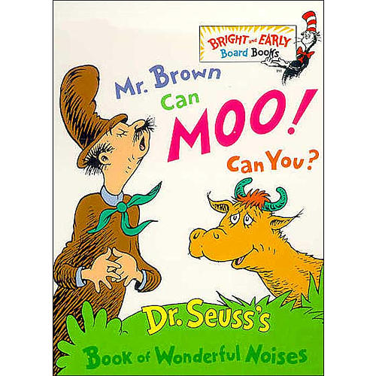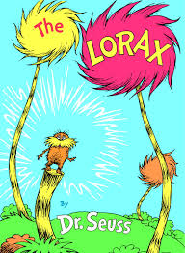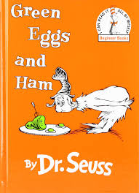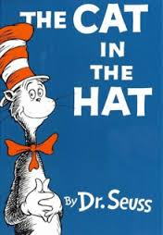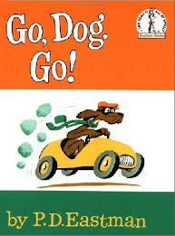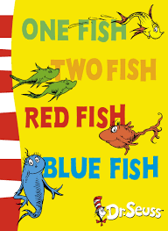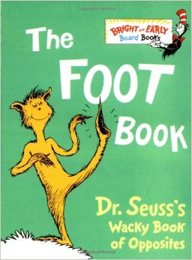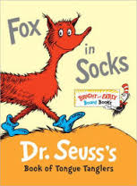

Dear Families,

Today we celebrated Dr. Seuss’s birthday as part of *Read Across America* week! We tasted green eggs and ham, wore our personalized “Cat Hats”, and practiced rhyming words just like Dr. Seuss did in his famous books. We also talked about rhyming pairs, which are words that sound the same at the end of the word, afterwards which we practiced making our own rhyming pairs.

Learning to rhyme is an essential part of your child’s literacy development! Research states that a child’s understanding of rhyme is directly linked with their success as a future reader. So what can you do to continue your child’s progress with rhyming skills? Practice at home! Pick out items at home that rhyme with each other. Practice in the car on the way to school. Be creative and have fun!

Always Learning,

Mrs. Grap