SHARED READING Lesson Plan with Skills Mini Lesson

GRADE LEVEL: Emergent Readers (First Grade)

SETTING: [ X ] WHOLE CLASS [ X ] SMALL GROUP [ X ] INDIVIDUAL

CURRICULAR AREA: Reading/Language Arts

LESSON TOPIC, CONCEPT, or SKILL: Phonemic Awareness

RATIONALE: Students need to develop their phonemic awareness through recognizing end-rhyming patterns. Rhyming teaches children how language works. It helps them notice and work with the sounds within words. Students are able to anticipate future rhyming words in books, which help them to make predictions when they read. To become literate, students need to develop these foundational skills, and phonemic awareness must be developed before students develop phonics knowledge. End rhymes help children to distinguish that rhyming sounds correspond to similar end letter patterns.

STANDARD(s):
RS.K.2. Phonological Awareness: Demonstrate understanding of spoken words, syllables, and sounds (phonemes). A) Distinguish long from short vowel sounds in spoken single-syllable words. B) Orally produce single-syllable words by blending sounds (phonemes), including consonant blends. C) Isolate and pronounce initial, medial vowel, and final sounds (phonemes) in spoken single-syllable words. D) Segment spoken single-syllable words into their complete sequence of individual sounds (phonemes).

ELD STANDARD(S):
PI.A.1.Em. Exchanging information and ideas: Contribute to conversations and express ideas by asking and answering yes-no and wh-questions and responding using gestures, words, and simple phrases.

PI.B.5.Em. Listening Actively: Demonstrate active listening to read-alouds and oral presentations by asking and answering yes-no and wh-questions with oral sentence frames and substantial prompting and support.

OBJECTIVE:
1. The students will be able to discriminate end rhyme sounds through using a picture match with 90% accuracy.

ASSESSMENT:
Formative assessment: The teacher will check for understanding during the shared reading of the book by having students participate in brainstorming different words that rhyme with some of the words in the book. The teacher will check for understanding before students yell out their rhyming word by asking for “thumbs-up” from students who have a rhyme in their head.
Summative assessment: Students will demonstrate their phonemic awareness of end rhymes by cutting out 10 pictures from a worksheet (5 matches total) and pasting the rhyming pictures next to each other on a new sheet of paper with at least 90% accuracy (4/5 correct).

VOCABULARY/ACADEMIC LANGUAGE NEEDED:
Rhyme: a correspondence of sound between words or the ending of words
Book: a written or printed work consisting of pages glued together

STRATEGIES TO SUPPORT ACADEMIC LANGUAGE DEVELOPMENT:
Choral Reading
Reading Aloud
Modeling
Pair Share
Guided Practice

STRATEGY: Shared Reading with Skills Mini Lesson

REQUIRED TEACHER BACKGROUND:
The teacher will need to be familiar with the rhyming patterns in the book And to Think that I Saw it On Mulberry Street, by Dr. Seuss, in order to effectively pause to allow students to join in with the rhymes in the second reading of the text. The teacher will need to be familiar with words that share end rhyming patterns, and will need to know what objects around the classroom share end rhyming patterns. The teacher will need to know the dynamics of the students in order to understand how they should work in pairs during discussion and in order to know which students need to work in a small group for extra support during the end activity.

TASK ANALYSIS: Students must be able to cut out pictures with scissors and glue them onto a new sheet of paper in a different order. Students must be able to look at a picture and determine the name of the object in the picture (For example: a picture of a tree is “tree”). Students must be able to work in partners and work individually. Students must know who their shoulder desk partner is before they sit down on the carpet for the shared reading time. Students must be able to recognize words that are read in the shared reading book and read them in tandem with the teacher. Students must be able to write their name on their piece of paper for the culminating activity and write the names of the pictures on the paper as well (dictation).

MATERIALS:
Big Book of “And to Think That I Saw it on Mulberry Street” by Dr. Seuss (or document projector to project the pages of a regular-sized version)
Scissors
Glue
Blank paper
Pencils
Colored Pencils for extension activity

PROCEDURES:

INTRODUCTION
Story Introduction Ask kids to come and sit down on the carpet because they are going to participate in the reading of a story. Ask kids to think about the street that they live on. Ask for volunteers to tell their shoulder partner what the name of the street they live on is. Then tell kids that they are going to participate in a story reading of “And to Think That I Saw it on Mulberry Street”, which incorporates a boy who sees a great deal of unusual things on Mulberry Street. Ask kids to make “thumbs up, middle, or down” if they know what a rhyme is. Provide wait time. Ask 2-3 kids for an example of words that rhyme with each other.

LESSON SEQUENCE
Reading

- Picture Walk Begin by slowly turning the pages of the book and directing students to look at the pictures of the book. Ask students if they see anything unusual in the pictures. Ask students if they can locate what the setting of the story is. Ask students who they think the main character of the book is. Read aloud 2-4 names of objects in the story that have end rhyming patterns to model to the students what they will be looking for during the reading of the story.

- Read Aloud/First Read (Read Aloud Lessons/Shared Reading Lessons) Slowly read through the entire story, using your finger to follow the words. This will allow the students to follow along and begin distinguishing patterns of words within the text. Emphasize the end rhymes of words within the text while reading. Refer to the predictions of the students about character and setting.

- Discussion Ask kids to talk with their partner about some noticeable details of the book. Allow time for discussion. Ask if students have ever seen _____(insert different objects that rhyme). Ask students to think of other nonsense words that they can rhyme with some of the objects in the story. Have students brainstorm in partners and then share-out with the class. Guide students to notice that the end patterns of words that rhyme have similar letters in them.

- Second Read The second reading will allow students to participate in the reading of specific words with end-rhymes. It will allow students to stay engaged and excited about the story, and provide ownership over the words that they repeat. The main purpose of the second read will be to have students identify rhyming words in the text. Opportunities for students to make up their own nonsense rhymes will be given.
Mini-Lesson

- Orientation After finishing the book, give students a moment to notice their surroundings. Point out that there are objects around us everyday, just like the objects in the story on Mulberry Street, that rhyme.

- Presentation Point out the chair in the room. Give students a moment to think of other objects in the room that rhyme with chair. Point to the teacher’s head to get students to say “hair”. Write chair and hair on the board for visual access to the words. Repeat this for chosen objects throughout the classroom, writing the rhyming words on the board for students to see. Continue to engage students in instructional conversation and pair share as students pick objects that rhyme with given objects around the room.

- Structured and Guided Practice Give students a few minutes in their partners to walk the room and look for objects that rhyme with one another. Allow students time for questions as the teacher roams the room with the students. Come back together on the carpet and have partners share their end rhymes with the rest of the class. If possible, students will bring their rhyming objects with them to the carpet to share with the class. The words for each of the rhyming pairs will be written on the board to guide into further instruction about the correlation between rhyming words and the similarity of end letters in words.

CLOSURE AND ASSESSMENT
4. Closure Ask students what the definition of a rhyme is according to the activities they have done so far. Ask students what the pattern is between rhyming words and the letters at the end of the words. Guide students to sit back down in their seats, telling them they need glue, paper, and a pencil at their desk to start the next activity. Hand out the papers with the pictures on them and walk through each picture with students, dictating to students how to write the names of each of the pictures underneath the picture itself. This will ensure that the students know the given name of each of the pictures. The teacher will model cutting and pasting of two rhyming word pictures that are not provided on the paper to the students so the students will understand what is expected of them.

- Independent Practice Students will individually work on their picture sort, without help from the teacher. They will cut each of the pictures out and paste them onto a new paper next to each other if they have end rhyming patterns.

5. Evaluation/Assessment Students will demonstrate their awareness of end rhymes by completing the picture matching activity to a 90% degree of accuracy. The teacher will collect their completed work and evaluate if the next lesson can move on in teaching steps of phonemic awareness, or if a re-teach of the content is required.

6. Differentiation
Students who need extra support (IEPs) will be taken into a small group in the back with an aide and allowed to work together as a group on this activity.
ELL students will be supported during this activity by having objects around the room labeled with their written names for the mini-lesson. They will be supported through the direction to write down the names of each of the pictures in the picture sort activity.
Students who need extra challenge (GATE) will be encouraged, after submitting their picture matching activity, to draw pictures of objects that have end-rhyming patterns. Students may be prompted with specific words if they are having trouble thinking of words that rhyme on their own

Picture Matching Activity:

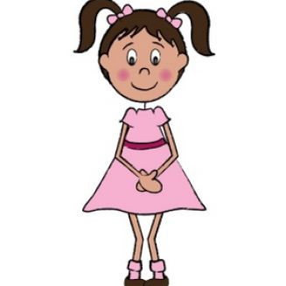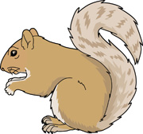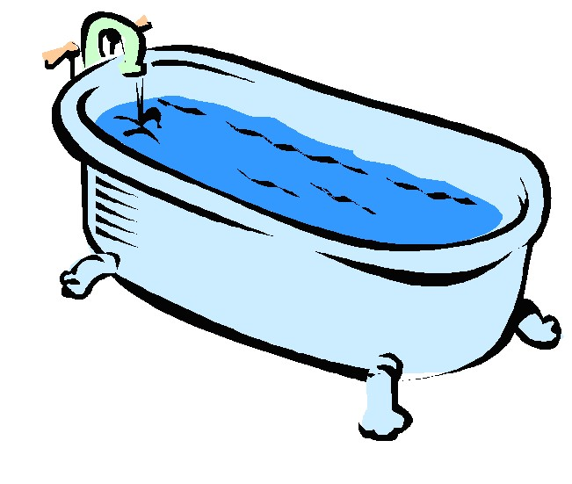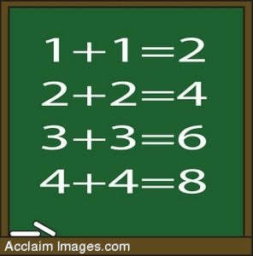

Book:
